A Survey on the Semi-automated Serious Educational Games
for a New Approach in the
Serious Educational Game Development Platform

TR xxxxx

Dr. Kendra Cooper

Golsa Mirbagheri

Acknowledgements

xxx.

Abstract

yyy.

Table of Contents

Acknowledgements 2
Abstract 3
Table of Contents 4
1. Introduction 6
2. Comparison Criteria 7
2.1 Validation: Serious Educational Game Assessment 7
2.2 Serious Educational Game Customization 7
2.3 Serious Educational Game Automation 7
2.4 Pedagogical foundation on Serious Educational Games 8
2.5 Serious Educational Games Content Generation 8
3. Automation in Game Applications 9
3.1 Serious Games 9
3.1.1 Fully Automatic Adaptation of Interfaces - The case of 1492 9
3.1.1.1 Introduction 9
3.1.1.2 Comparison Criteria 10
3.1.2 Semiautomatic Adaptation - The case of "My first day at work" 11
3.1.2.1 Introduction 11
3.1.2.2 Comparison Criteria 12
3.1.3 Petri Nets for Representing Story Plots in Serious Games 13
3.1.3.1 Introduction 13
3.1.3.2 Comparison Criteria 15
3.1.4 Applying Cellular Automata and DEVS Methodologies to Digital Games 15
3.1.4.1 Introduction 15
3.1.4.2 Comparison Criteria 18
3.2 Entertainment Games 18
3.2.1 Modeling Player Experience for Content Creation 18
3.2.1.1 Introduction 18
3.2.1.2 Comparison Criteria 20
3.2.2 Towards Automated Game Design 21
3.2.2.1 Introduction 21
3.2.2.2 Comparison Criteria 23
3.2.3 Level content generation 24
3.2.3.1 Introducion 24
3.2.3.2 Comparison Criteria 26
3.2.4 An Offline Planning Approach to Game Plotline Adaptation 27
3.2.4.1 Introduction 27
3.2.4.2 Comparison Criteria 29
4. Automation in E-learning Application 30
4.1 Automating e-Learning: The Higher Education Revolution 30
4.1.1 Introduction 30
4.1.2 Comparison Criteria 32
4.2 Recommender system based on user-generated content 33
4.2.1 Introduction 33
4.2.2 Comparison Criteria 34
4.3 E-learning recommendation system 35
4.3.1 Introduction 35
4.3.2 Comparison Criteria 37
4.4 EXPERT PERSONALIZED E-LEARNING RECOMMENDER SYSTEM 37
4.4.1 Introduction 37
4.4.2 Comparison Criteria 39
5. Conclusions and Future Work 39
5.1 Table of Comparison Criteria 39
6. References 41
Appendix A. title here 43

Introduction

// a place to start is one paragraph for each of these:

Intro. to changing educational needs, how e-learning fits into that shift (include definition with reference for e-learning)
Intro. to serious educational games (include definition with reference of serious educational game)
Intro. to automation in serious education games (what other researchers have automated)
Intro. to the SimSYS Game Development Platform (overview, with references)
Focus in on the intelligent semi-automated game generation component
Why is this research needed?
Brief overview of the component, research methodology (including validation), and results
Structure of this report

Comparison Criteria

Validation: Serious Educational Game Assessment
Assessment has become a subject of great interest to engineering educators. This is part of a larger trend toward emphasizing student learning outcomes in higher education, undertaken both to demonstrate accountability and to improve instruction. Traditionally, engineering educators have focused assessment around students' mastery of content knowledge and skills. IEEE
Internal educational validity indicates to what extent learners achieve the learning/performance/skills expected by the game/simulation (e.g., decision-making skill, prediction accuracy, cooperation, motivation). The measures can be either the performance indicator provided by the game/simulation (e.g., total sales, total profit), or the ones designed based on the expected outcomes from the game/simulation. External educational validation refers to whether the learning/skills expected by the game/simulation matters or relevant in the real world? Representational validity is the basis of educational validity. However, a high representational validity does not necessarily lead to high educational validity. On the contrary, high representational validity (e.g., high fidelity and complexity) may lead to low educational validity (i.e., poor learning) for certain learners. Some people may approach the validation in a simpler way by assessing the game/simulation in terms of a series of desirable learning outcomes/skills, and see which one(s) the game/simulation is effective in improving.

Serious Educational Game Customization
User interfaces to games embody the practice and experience of interfacing users (game players) to both the game system and the play experience designed by the game's developers. Game developers act to constrain and govern what users can do, and what kinds of experience they can realize. Some users in turn seek to achieve a form of competitive advantage during game play by modding the user interface software for their game, when so enabled by game developers. These modes acquire or reveal additional information that users believe will help their play performance and experience. User interface add-ons subsequently act as the medium through which game development studios support game product customization, which is a strategy for increasing end-user satisfaction and thus the likelihood of product success.
Three kinds of user interface customizations can be observed. First and most common, is the player's ability to select, attire or accessorize a player's in-game identity. Second, is for players to customize the color palette and representational framing borders of their game display within the human-computer interface. Third, are user interface add-on modules that modify the player's in-game information management dashboard, but do not modify the underlying game play rules or functions.

Serious Educational Game Automation
Automated Verification System: A software tool that accepts as input a computer program and a representation of its specification and produces, possibly with human help, a proof or disproof of the correctness of the program. Any software tool that automates part or all of the verification process. IEEE
scientific methods and technologies that improve efficiency, productivity, quality, and reliability, specifically for methods, machines, and systems operating in structured environments over long periods, and the explicit structuring of environments. Research includes topics related to robots and intelligent machines/systems in structured environments and the explicit structuring of environments, and topics at the Operational/Enterprise levels such as System Modeling, Analysis, Performance Evaluation; Planning, Scheduling, Coordination; Risk Management; and Supply Chain Management. IEEE

Pedagogical foundation on Serious Educational Games
In pedagogical foundation on Serious Educational Game, 5 areas called prediction-observation-explanation (POE), Self-explanation, Collaboration, Problem-Based Learning (PBL) and Guidance, reflection, and interactivity will be evaluated.

- The prediction-observation-explanation (POE)
A prediction-observation-explanation model is a potential approach to increase learners’ conceptual change.
- Self-explanation
Self-explanation is a method that prompts students to generate their own explanation orally, in writing, or through replying to a multiple-choice question.
- Collaboration
Collaboration refers to a situation that two or more students work together on constructing knowledge and solving problems. In a game environment, collaboration enables players to guess and discuss about game moves, strategies, or arguments.
- Problem-Based Gaming (PBG)
Problem-Based Learning (PBL) is an ideal way to engage learners in cognitive processes so that they can build knowledge or develop skills to solve problems effectively.
- Guidance, reflection, and interactivity
The researchers conducted three experiments to investigate how students’ deep learning was enhanced in an agent-based multimedia game that integrates instructional methods: guidance (the agent explains why an answer is accurate), reflection (learners are prompted to explain why an answer is accurate), and interactivity (learners are asked to respond to a problem instead of receiving an answer from the agent). The results show that ether guidance or reflection was able to support students’ science learning in a game context. In addition, reflection also fostered retention and far transfer only when the students were encouraged to reflect on the correct solutions provided by the agent (interactivity). That is, if asked to reflect on their own solutions, the students might not benefit from playing the game.

Serious Educational Games Content Generation
Procedural content generation (PCG) is an increasingly important area of technology within modern human-computer interaction (HCI) design. Personalization of user experience via affective and cognitive modeling, coupled with real-time adjustment of the content according to user needs and preferences are important steps toward effective and meaningful PCG. Games, Web 2.0, interface, and software design are among the most popular applications of automated content generation. IEEE
Content creation involves work with the information structure, navigation, taxonomy and categorization of content. Content either needs to be created new from scratch, or must be imported from an existing Web site, or both. Content creation can start when the editors are prepared, and when the technical environment is sufficiently ready. The content work will then most likely continue beyond the technical delivery and acceptance of the Web site. Content can be of many kinds but is typically text and images in different formats – web pages, documents (Word, pdf...), sounds, animations etc. Normally the customer manages the content input to the new Web site, but the partner may also assist in this part. In most cases it is not a problem to work with content and development at the same time on the test server, as long as user have an active communication in the project team so that everyone is aware of what is going on.

Automation in Game Applications

Serious Games

Fully Automatic Adaptation of Interfaces - The case of 1492

Introduction
In this section the need for tools will be discussed that assist educators and educational content providers in producing games that are equally accessible for all. The goal is to minimize the cost and effort needed for introducing accessibility in serious games. It will be discussed to what extent the process of making a serious game accessible can be automated and supported by software tools that minimize human intervention. It is concluded that there is a set of common accessibility barriers, especially those related to interaction and physical disabilities that can be addressed systematically in a high proportion and therefore could be dealt with by software. In this section two user profiles are considered: blind users and users with a motor disability. Among the wide variety of levels of visual impairments, it’s characterized the blind user profile as users that needed the aid of screen reading software to use a computer. Users with a motor disability as those needed of using voice recognition software to interact with a computer due to reduced or lack of mobility. Both user profiles encounter barriers when interacting with point-and-click applications as they are not able to use the mouse.
The game author was only allowed to enable or disable the modules during the exportation process. All the adaptation to the user profile was performed automatically by analyzing the game description XML files and art resources (see Fig.3.1).
The results were two new modalities which had common inner workings. The interaction was performed through short commands formulated in natural language (e.g. "grab the notebook" or "talk to the character"). An interpreter received the commands, executed them if they were correct, and provided feedback about the results using the appropriate channel for the active user profile (auditory for the blind user through a built-in text-to-speech engine, text for the user with a motor disability). Blind users introduced the commands using the keyboard, while users with a motor disability used speech [3].

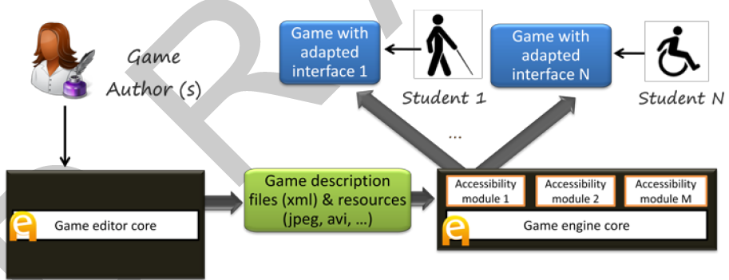
Game engine Core

…
Accessibility module 1
Accessibility module M
Game editor Core
Game description files and resources Core
Game Author

Game with adapted interface 1
Game with adapted interface N

Student 1
Student 2
Fig 3.1. Basic accessibility architecture. Accessibility was provided by specific input/output modules integrated with the engine, which are activated when the game was exported [3].
Command processing was directed by a regular grammar combined with a fixed list of synonyms for relevant verbs (actions) and nouns (interactive elements). The regular grammar was automatically generated from the description of the game, taking the actions defined for the interactive elements available in each game scenario.

Comparison Criteria

Validation: Serious Educational Game Assessment
No validation module has been implemented in this approach.

Serious Educational Game Customization
The goal is to minimize the cost and effort needed for introducing accessibility in serious games. In accessibility architecture. Accessibility was provided by specific input/output modules integrated with the engine, which are activated when the game was exported [3].

Serious Educational Game Automation
In the case of 1994, all the adaptation to the user profile was performed automatically by analyzing the game description XML files and art resources. The regular grammar was automatically generated from the description of the game, taking the actions defined for the interactive elements available in each game scenario. (refer to table)

Pedagogical foundation on Serious Educational Games
In this approach no pedagogical foundation method is used.

Serious Educational Games Content Generation
In this approach no method is used for creating content.

Semiautomatic Adaptation - The case of "My first day at work"

Introduction

Another experiment which was resulted in the game "My first day at work", developed in collaboration with Technosite, a company of the ONCE (National Organization for the Blind in Spain) group. In Fig. 3.2, flexibility of the accessibility features was improved that now could be configured with the game editor [3].
In addition to the blind and motor disability profiles, a new user profile was considered: users with low vision. Colleagues from Technosite identified the adaptations this profile needed, which included screen and text magnification and use of a high contrast color scheme.
"My first day at work" was focused on meeting the needs of the three be-spoken profiles (blind, motor disability and low vision), it has been tried to make it accessible to users with cognitive disabilities (e.g. Down and Asperger syndromes).

Game editore Core

……..
...
..

…
Additional description files (xml) + alternative resources
Game Author
Access config tool 1

Game engine Core

…
Game description files and resources Core
Accessibility module 1
Accessibility module M
Access config tool X
Game with adapted interface 1
Game with adapted interface N

Student 1
Student 2
Fig. 3.2. Improved architecture and workflow. The accessibility features are now configurable from the editor to match different user profiles. The editor also produces automatically additional description files and resources [3].
Dealing with these problems is much more complicated and there is little room for automation. The eAdventure adaptation engine was used to provide alternative paths in the game with different levels of difficulty, or alternative versions of text intensive components such as conversations [3].

Level of automatic and semi-automatic adaptation
Table 1 shows a summary of the adaptations performed. Adaptations related to the modality, how the user interacts with the game or perceives the game feedback are prone to be automated (e.g. interfaces for blind users and users with reduced mobility).
To make it accessible for users with low vision it was needed to produce alternative versions of 53 art resources, an increase of 7,57%. Although this value is not very high it could increase exponentially if more profiles were considered (e.g. users with color blindness), so it is important to keep the number of manually crafted alternative resources as low as possible [3].

Table 3.1. Summary of adaptations performed for each profile. Table reflects what aspect of the game were affected and the level of automation achieved[3].
Profile | Aspect | Adaption (s) | Automation
Blind | Interaction / modality | New interaction and adapted return of information | High
Motor disability | Interaction / modality | New Interaction | High
Low vision | Interface / rendering pipeline | High contrast rendering filters, magnification, alternative images and color schemes | Medium
Cognitive disability | Game design and content | Lessened difficulty of puzzles, alternative version of texts | Low

Comparison Criteria

Validation: Serious Educational Game Assessment
No validation module has been implemented in this approach.

Serious Educational Game Customization
The goal is to minimize the cost and effort needed for introducing accessibility in serious games. In accessibility architecture, accessibility was provided by specific input/output modules integrated with the engine, which are activated when the game was exported [3].

Serious Educational Game Automation
In the case of "My first day at work”, the accessibility features are now configurable from the editor to match different user profiles. The editor also produces automatically additional description files and resources[3]. ( refer to table)

Pedagogical foundation on Serious Educational Games
In this approach no pedagogical foundation method is used.

Serious Educational Games Content Generation
In this approach no method is used for creating content.

Petri Nets for Representing Story Plots in Serious Games

Introduction
This part describes a novel technique for representing plots of stories in computer games and for unfolding stories according to these plots. The technique is based on Petri Nets. Its main advantages are: 1) it copes well with branching stories, which 2) can evolve in parallel in 3) large virtual worlds. While the issue of branching stories has been already studied in literature, the latter two issues have not been sufficiently addressed yet. The technique has been evaluated on a prototype implementation, and subsequently used in two serious games Europe 2045 and Karo. Europe 2045 is an on-line multi-player strategy game aimed at education of high-school students in economics, politics, and media studies, which is presently evaluated at high-schools in the Czech Republic. Karo is a storytelling simulation that is intended to engage students in decision making concerning social relations, and work on it still continues. While Europe 2045 simulates Europe in a coarse-grained way, Karo features a detailed virtual world inhabited by virtual humans. Besides presenting the Petri Nets modifications used in the prototype and in both of the games, the section details several scenarios from the games, and on a general level, it discusses the strengths and weaknesses of implementation of Petri Nets in virtual storytelling applications.
In this part, the different perspectives of a designer, who use Petri Nets as a specification tool, and a programmer, who use it as an architectural underpinning of the story manager, are emphasized.
Petri Nets is a specification technique frequently used in software engineering. A basic variant of it consists of containers (or places, represented by a circle), tokens (“the pellets”), actions (or transitions), and transition function. The containers contain the tokens. If a sufficient number of tokens is contained in specific containers, an action is triggered. After firing an action, the tokens that helped to fire this action are removed, and some new tokens are generated (see Fig. 3.3a). Which tokens fire which action and which action generates tokens to which containers is specified by the transition function (and depicted by arrows).
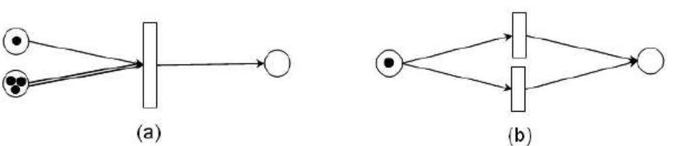
Figure 3.3: Petri Nets examples. a) The action generates one token if there is one token in the upper container and two in the lower container. b) The two actions are in conflict.

Petri Nets for Representation of Story Plots
For purposes of each particular storytelling application, it is beneficial to develop a particular modification that fits best for what the application demands.
First it’s described in detail a particular refinement of Petri Nets, based on so-called timed coloured Petri Nets. In fact, this refinement is used for prototyping purposes formerly, which allowed to conclude that Petri Nets are a fruitful technique in the storytelling domain.
To set the terminology, a PNA-model is the type of Petri Nets formalized in this section, and a PNA-plot is a specification of an individual plot by means of the PNA-model. Every PNA-plot can be loaded from an xml-file by an application called TEST that is developed, which features an abstract story manager for running and verifying PNA-plots. TEST works as follows: After a PNA-plot is loaded and the simulation started, events start to occur according to the PNA-plot in an abstract manner. That means that the TEST computes the story next function (1), but there is no simulator of a virtual world to compute the world next function (2). The result of this function is to be determined manually by a user through a check-box like interface in TEST; this mimics the changes that would be imposed on the world by the simulator or a user interacting with the world in case of a full-fledged application.

Europe 2045: Europe 2045 is an on-line multiplayer game aimed at education of high-school students in economics, politics, and media studies. The developmental phase is completed and the game is presently being evaluated.
The preliminary model was extended by presenting the PNB-model, which was used as a plot specification technique in the full-fledged serious game Europe 2045. Presently, this game features one 10-round, fully developed campaign, which comprises about 70 game events (affairs, or news items). This allows users to conclude that in this section, fruitfulness of Petri Nets is demonstrated in the domain of social-economical serious games.
The plot of the mentioned campaign was actually coded directly in PHP. This helped users to start quickly, but it also presents a limitation. To facilitate the development process, that is benefited from a graphical authoring tool, especially because it’s aimed at creating a second campaign and several undergraduate humanities students, who do not know PHP, develop other campaigns as a part of their university course. Developing this tool presents the future work.

Karo: Karo is a simulation featuring virtual humans intended as a serious game for civic. Particularly, it should help students to understand dynamic of social relationships. Presently,
it should be regarded as a research prototype, not a full-fledged application. Contrary to Europe 2045, programming work on Karo still continues.
In this study, the PNA-model was extended by presenting the PNC-model, which was used for developing a case-study scenario in Karo game. The main innovation in the
PNC-model is hierarchical nesting of Petri Nets. While this work is still in progress concerning its educational side and particularly the claims that “small influences can change the outcome of the story radically” and that this “has an educational potential”, the experience gained so far allows as to state that Petri Nets can be and in fact have been scaled for unfolding stories in an application featuring virtual humans.

Conclusion: In this section, it have described a method for specifying branching plots of scenarios that can evolve in parallel, i.e. in several different places at the same time. The method is specifically designed to cope with stories being unfolded in large virtual worlds.
While the PNB-model have demonstrated the practical usefulness of Petri Nets as a plot
representational technique in the domain of serious games, the PNC-model have showed
their scalability for an application featuring virtual humans. Apart from the ability to represent branching plots that can evolve in parallel, the strength of Petri Nets is that they are formal and yet can be presented graphically. It have found them as easily comprehensible by non-IT experts; not only the chief designer of Europe 2045 does not have IT background, but the technique was also explained to college students of humanities during a course (during about an hour and half) and they were subsequently able to use it to specify their own “toy” campaigns.

Comparison Criteria
Validation: Serious Educational Game Assessment
The fruitfulness of Petri Nets was evaluated in storytelling in general. The evaluation took place on the application TEST that allowed for running PNA-plots in an abstract manner, i.e. without any virtual world connected to it.

Serious Educational Game Customization
As mentioned before, no accessibility was used to minimize the cost and effort needed for student with physical problems.

Serious Educational Game Automation
No automation method has been used in this approach.

Pedagogical foundation on Serious Educational Games
“Interactive–narrative” tension was solved by limiting the degree of interactivity available to a user. It was allowed the user to participate only by changing emotions, moods, and relationships of the characters, and by modifying the environment slightly, e.g. by moving objects.

Serious Educational Games Content Generation
In this approach no method is used for creating content.

Applying Cellular Automata and DEVS Methodologies to Digital Games

Introduction
The purpose of this section is to survey how cellular automata and its variant, called cell-DEVS (discrete-event systems specifications), may be used to implement computer simulations that can be used as digital serious games. The implementation is illustrated that through some of the practical applications of such cellular automata.
A cellular automaton is a very simple abstraction invented to study self-reproducing systems. Since then, cellular automata (CA) have been widely used to reproduce and better understand the dynamics of complex phenomena found in the real world, especially when these phenomena only require very simple programming to be reproduced digitally. In this part, an extension of the CA is described that compensates for this missing structure by means of another simple but equally powerful mathematical abstraction called discrete-event systems specifications (DEVS).
Cellular models and DEVS can provide enhanced capabilities in the development of serious games applications. In this section, it will be given different examples in this field. The idea of this section is to show how CA and DEVS models can be used to create varied serious games samples, focusing on the methods and techniques employed in developing those models.
In this section, it will be introduced different cellular models applications with the goal of answering the questions above. These varied models have been developed and simulated with the CD++ environment, and they illustrate the potential of applying CA and DEVS-based methodologies in serious game development.

A Simple Model of Bouncing Balls: In this section, the basic definitions of Cell-DEVS models are shown by defining the behavior of balls bouncing within a container. The model is specified by a 20 × 20 cell space using the CD++ specification language. The model defines nine sets of rules to control the movement of balls, including four sets of rules for the corner and border cells each as well as a set of rules for the rest of the cell space.
Psection Collision:This model uses a lattice gas to define a 2D cellular model of the collision of psections. This kind of model can be used to study the psection collision of gas fluids, where different types of fluids are mixed together in a container. Each cell uses a double value that consists of an integer part and a fraction part. The integer part represents four possible moving directions of a psection (1:E, 2:N, 3:W, 4: S), whereas the fraction part represents the purity of the fluid. The collision of two psections modifies not only their direction but also the degree of purity of the corresponding fluids.
Gossip Propagation: This model represents the propagation of a piece of gossip (or information) by a group of people, using the flow of information from a single source to a group of sinks (i.e., receivers). The information only propagates to interested parties from someone who has already heard the gossip.
The Cell-DEVS model of this gossip propagation uses two bidimensional square grids. The bottom layer grid represents the people, who will be either active or passive based on whether or not they know the gossip. The second layer is used to hold the probabilities of spreading the gossip. The cell neighborhood can be either a Moore or a von Neumann neighborhood (i.e., the cells to the N/S/E/W). Each cell in the inverse neighborhood has a random chance of being told the gossip from a cell that knows it. This prevents the model from evolving the same way in every execution. This random number is obtained from the layer above. This model is defined by the three following rules for cells:
1. If a cell is passive, and cells are active in its inverse neighborhood, the cell may become active.
2. If a cell is active, it will remain active.
3. A cell that knows the gossip is unlikely to forget it.
Human Behavior at a Metro Station: This model represents the movement of persons waiting for a train in a metro station. As more people arrive, they tend to concentrate at the two boarding doors. Two groups of people are formed around the boarding doors at the border of the platform waiting for the doors to open. When the train arrives, the people leaving the train have a higher priority than those trying to get into the train. Therefore, if someone is leaving the train, the people waiting at the platform start to move to let them leave. In the same way, collision detection is used such that if people try to get into the train at the same time, only one of them gets the access.
Voters: In this game, it’s represented how voters’ political preferences are influenced by others in a constrained environment using a 2D cellular model. The voters can either stick to their current political preferences or change their preferences based on the influence of their neighbors. Each cell stands for a voter who is under the influence of four neighbors as defined by a Von Neumann’s neighborhood. The rules that control future political preference have two parts:
(a) voters stick to their previous political preference according to a global probability
parameter (e.g., 50%) and (b) if the voter decides to change the political preference, one of the four adjacent neighbors is picked randomly with equal probability (i.e., 25%) and this neighbor’s current preference value is assigned to the voter.
The Daisy World: The Daisy World model is a game that can be used to study the principle of self-regulation and the effect of planetary life on climate change. An imaginary planet, called the Daisy World, is populated solely by black and white daisies. Black daisies warm up the planet by absorbing heat, while white daisies cool it by reflecting heat. As the planet’s sun warms up, the daisies maintain a moderate temperature by altering the balance between the black and white. Eventually, as the sun gets too hot, no daisy can survive
and all life dies out on the planet.
Sandpile Modeling: CA models have been used to study the formation of sand piles in the event of landslides caused by major. Here, it’s shown the definition of one of such CA proposed in, built as a coupled model consisting of a cellular model component (representing and a DEVS atomic component that serves as a sand generator.
3D Free-Form Shape Modeling: 3D free-form shape modeling has been used in various applications such as computeraided design systems and mechanical engineering. However, modeling free-form shapes in 3D space involves considerable computation based on simplified physical laws. In this section, it will be shown how to apply cellular models for the compression (from outside) and deformation (from inside) of a virtual clay model.
The deformation process is the result of clay transportation from high-density areas to low-density areas. In the cellular model, each cell has a positive value corresponding to the mass of clay contained in the cell. A cell with value above a predefined threshold will transfer clay to its neighboring cells. The model defines a Margolus neighborhood for the cells. The 2D Margolus neighborhood is a block that includes the nearest four cells. Cells belonging to the same block will perform state transitions together at each step. In addition, block boundaries change depending on whether the transition is performed at an odd or even step. Hence, the neighborhood of each cell alternates between its odd and even configuration at every transition step.
Each cell has a binary state reflecting whether it has a mass of clay above or under the threshold, creating four different block patterns of clay transitions in the 2D neighborhood. The block patterns are more complex in the 3D Margolus neighborhood, including 21 different transition rules.
In this part, it was surveyed how DEVS and its cell-DEVS variant can be used to implement CA in computer simulations. In particular, the multiple was emphasized benefits of using a DEVS approach for the development of serious games. Because of its rigorous formalization and continuing standardization, DEVS favors content sharing and interoperability in the development of serious game applications. In addition, DEVS also makes it easier to realize virtual world evolution in the simulations, thanks to its modular model construction capability and explicit separation of business logic (models) and simulation implementation. As DEVS is based on the discrete-event simulation paradigm, it allows for improving the efficiency of terrain generation without losing accuracy. Finally, DEVS-based simulations can be transparently executed in parallel and distributed computing environments by taking advantage of advanced PADS techniques; it can help reduce the simulation time significantly at reduced cost.
Also, in this part, it was illustrated some of the practical examples that make use of such cellular models in Serious Games applications, ranging from simple ones such as the bouncing ball to more sophisticated ones such as crowd behavior and 3D shape deformation. The variety of these use cases demonstrates the potential of using DEVSbased cellular M&S for studying real-world systems, situations, or phenomena. It also demonstrates how such models can be easily expressed using simple constructions and rules. The ability to express a given model at ease is a clear invitation to experiment with new models and to discover that simple local rules are often sufficient to explain the most complex and sometimes counterintuitive phenomenon observed in the real world.

Comparison Criteria
Validation: Serious Educational Game Assessment
No validation module has been implemented in this approach.

Serious Educational Game Customization
No customization has been implemented in this approach.

Serious Educational Game Automation
The fundamental idea behind this CA model is to use a network of identical elements, named cells, each having its own individual state and sharing the same set of transition (evolutionary) rules. The transition rules decide the next state of a cell based on its current state and the current state of its neighboring cells in the network; rules are applied synchronously to every cell of the network. Hence, the resulting cellular automaton evolves step by step, and each such evolution is called a generation.

Pedagogical foundation on Serious Educational Games
In this approach no pedagogical foundation method is used.

Serious Educational Games Content Generation
It’s used a client/server architecture in which one updates the code at the server side so that game content enhancement can be performed in a centralized and safe way. The hierarchical and modular approach of the DEVS methodology lends itself naturally to introduce —in terms of simulation safety, module modification, player contribution, and development cost effectiveness. By separating the business logic from the application implementation, these rule-based tools allow for content enhancement without jeopardizing the underlying simulation system. DEVS favors content sharing and interoperability in the development of serious game applications.

Entertainment Games

Modeling Player Experience for Content Creation

Introduction
In this part, it’s used computational intelligence techniques to built quantitative models of player experience for a platform game. The models accurately predict certain key affective states of the player based on both gameplay metrics that relate to the actions performed by the player in the game, and on parameters of the level that was played. For the experiments presented here, a version of the classic Super Mario Bros game is enhanced with parameterizable level generation and gameplay metrics collection.
Player pairwise preference data is collected using forced choice questionnaires, and the models are trained using this data and neuroevolutionary preference learning of multilayer perceptions (MLPs). The derived models will be used to optimize design parameters for particular types of player experience, allowing the designer to automatically generate unique levels that induce the desired experience for the player.

Modeling of player experience are considered as a whole to be of utmost importance for making automatic content generation techniques more sophisticated and usable. The work was described in this part is novel in that computational models of player experience are constructed which are derived from gameplay interaction and can be used as fitness functions for game content generation. For that purpose, it’s been used a modified version of a classic platform game for the experiments and collect player data through the Internet.
This part significantly extends in which the core ideas of the methodology proposed are outlined and, in which only three affective states are analyzed and only using single-layer perceptrons (SLPs) and less sophisticated feature selection.
The focus and main contribution of this part is introducing a refined method for player experience modeling, and exemplifying how it can be used for a well-known game. The particular models are only meant to be valid for this game, and possibly closely related games, whereas the method could be generalized to games in many different genres as well as for modeling the experience of user–computer interaction in general.

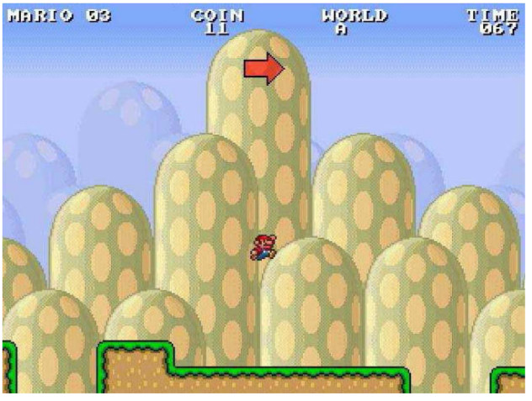
Fig 3.4.Testbed game screenshot, showing small Mario jumping over a piece
of flat terrain surrounded by two gaps.

MODELING OF PLAYER EXPERIENCE PREFERENCES
This section presents the two-phase procedure followed towards modeling player experience. The ultimate aim of this study is to control for level generation based on player experience. On that basis, it is desired that level features and game mechanics are adjusted dynamically so that the player experience (output value of MLPs) is optimized.
For that purpose, all four controllable features (if not already selected from the first phase) are forced into the input vector of the MLP which includes the feature subset selected via the SLP modeling procedure. The rationale behind this two-phase approach is threefold: 1) Expressiveness of SLP models. 2) Computational effort 3) Representation completeness

A. SLP Models: Feature Selection
The correlations calculated above provide linear relationships between individual features and reported emotions. However, these relationships are most likely more complex than can be captured by linear models. All evolved networks performed much better than networks with random weights, which reached chance level prediction accuracy. As a general observation, sequential forward selection appears to be the most appropriate feature selection mechanism for all six emotions. SFS develops feature subsets that feed SLP models which achieve the highest cross-validation performance.
Even though SFFS is a more efficient hill climber which allows backward search it does not showcase that advantage in small feature sets (e.g., less than eight features) as the ones examined in this part. Note that SFFS performance is different from SFS performance only in challenge prediction since two backward steps occurred during that run; no successful backward step was performed in any other affective state predicted resulting in equal performance values for SFS and SFFS. SLP predictors of each affective state are Fun and Challenge.
B. MLP Models: Optimizing Topology
In particular, reported fun, challenge, frustration, predictability, anxiety, and boredom were approximated with respective accuracies of 69.18%, 77.77%, 88.66%, 76.28%, 70.63%, and 60.87% using SFS as the feature selection mechanism.
All remaining controllable parameters which are not included in the selected feature subset are forced into the input of MLP (rather than SLP) models of emotional preferences and their topologies are optimized for maximum prediction accuracy. MLPs have the advantage of universal approximation capacity; in particular, combinatorial relationships (such as XOR) can be represented.
MLP topologies of two hidden layers, with up to 30 and ten hidden neurons, respectively, in the first and second layers are investigated; this sums to 330 different topologies which are tested for each input vector (feature set selected from SLPs plus the remaining controllable features). In general, it is worth noticing that the networks have a wide variety of sizes: from the relatively small networks of fun and challenge, to the moderate-sized MLPs of predictability and anxiety, to the large MLPs of frustration and boredom. Independently of size, all MLP models exhibit an improvement in their performance compared to the corresponding SLP models .The best topology found for each affective state varies a lot across all six emotions showcasing, in part, the complexity of predicting the preferences of users for each affective state individually.

The work reported in this part introduces data-driven computational models that predict several dimensions of player experience based on both level design features and gameplay metrics. The work also constitutes the first player experience study in the context of a platform game; follow-up experiments will be the first where game levels are generated based on quantitative player experience models. While the experiments were successful in the sense that the predictors achieved high accuracy on core aspects of player experience using threefold cross validation, there are potentially ways to further increase those models’ performance. As noted above, gathering data from more gameplay sessions could assist in the process of improving these cognitive models of player experience. However, given the challenges of accurately capturing the user’s affective state reported in the literature.

Comparison Criteria

Validation: Serious Educational Game Assessment
The performance of each user model is measured through the average classification accuracy of the model in three independent runs using the threefold cross-validation technique on the three possible independent training and validation data sets.

Serious Educational Game Customization
The ultimate aim of this study is to control for level generation based on player experience. On that basis, it is desired that level features and game mechanics are adjusted dynamically so that the player experience (output value of MLPs) is optimized. For that purpose, all four controllable features are forced into the input vector of the MLP which includes the feature subset selected via the SLP modeling procedure.

Serious Educational Game Automation
The derived models will be used to optimize design parameters for particular types of player experience, allowing the designer to automatically generate unique levels that induce the desired experience for the player. The modeling of player experience was considered as a whole to be of utmost importance for making automatic content generation techniques more sophisticated and usable. While implementing most features of Super Mario Bros, the standout feature of Infinite Mario Bros is the automatic generation of levels.

Pedagogical foundation on Serious Educational Games
No pedagogical has been used in this approach.

Serious Educational Games Content Generation
A modified version of a classic platform game was used for the experiments and player data was collected through the Internet. The content generation could also be part of the game and done online, serving players new game content such as levels and game modes based on how they individually have played previous levels. At the extreme of online content creation, levels could be modified in real time by, e.g., removing or adding enemies, obstacles, shortcuts, items, etc.

Towards Automated Game Design

Introduction
In this section, it is described an approach to formalizing game mechanics and generating games using those mechanics, using WordNet and ConceptNet to assist in performing common-sense reasoning about game verbs and nouns. Also it’s demonstrated and described in detail a prototype that designs micro-games in the style of Nintendo's WarioWare series. For WarioWare-style generator, it has been chosen to focus on theme as the guiding aspect. Design goals are specified in terms of nouns and verbs; the generator's job is to create micro-games that are \about the verb and/or noun. Since a micro-game instantiates a single, atomic game mechanic, and maps real-world referents onto this mechanic, such games are a nice vehicle for exploring the common-sense reasoning issues that arise in the thematic aspect of game design.

Generating WarioWare-style games
Although WarioWare-style micro-games are quite simple structurally, usually containing one or two pieces of abstract mechanics and lasting for no more than a few seconds, they are an example of a game style that actual game designers work on and release commercially (rather than an artificial toy domain), with a design space that touches on a wide cross-section of issues in game design. Their abstract simplicity allows users to focus on the thematic elements of game generation, and the fact that they are lightweight games that are easy and quick to play meshes well with a number of potential applications, such as web-distributed casual games and customized cell-phone games.

Common-sense thematic content
Generating a game that fulfills the request is now a combination of two common-sense problems: The game should \make sense" in terms of the roles its thematic elements are playing, and it should be \reasonably close" to what the user requested. To address both problems, it’s used a combination of the ConceptNet and WordNet knowledge bases. ConceptNet is a graph-structured common-sense knowledge base mined from OpenMind a collection of semi-structured English sentences expressing common-sense facts gathered from online volunteers. ConceptNet's nodes are English words or phrases, and links between them express semantic relationships such as (CapableOf "person" "play video game"). WordNet is a similarly graph-structured knowledge base (Concept-Net's structure was based on WordNet's), but it positions itself as a dictionary rather than as a semantic knowledge base. Nonetheless, it contains semantic information in the form of word hierarchies, where a word below another one in the hierarchy is a specialization of the higher-up one (the higher word is a \hypernym", and the lower one a \hyponym" if a noun, or \troponym" if a verb).
This information add inheritance to ConceptNet queries: If something is true of animals in general, then it is true for specific kinds of animals as well. Since ConceptNet knows that an animal can be shot, WordNet-based inheritance lets users figure out that a pheasant, as a specific kind of animal, can also be shot. In addition to using WordNet to extend ConceptNet's coverage, its hypernymy relationships is used to determine simple attributes, such as whether a noun is animate (if it is, it will be below \animate thing" in the hierarchy). Finally, distances between nouns and verbs are been used in WordNet and ConceptNet, respectively, as simple measures of similarity: WordNet for nouns (due to its fairly comprehensive taxonomy) and ConceptNet for verbs (since this captures more complex notions of similarity such as \can operate on the same object). While link distance is a simple notion of similarity, it has worked well as a first approximation.

Decomposing WarioWare
To facilitate generation, a number of styles of WarioWare games are abstracted into abstract game types; currently the system knows about three of them. An Avoid game is one in which one entity, the \avoider", must avoid (for the duration of the game) one or more other entities, the \attackers", which may attack the avoider either directly or via other objects. The player can play either role. An Acquir game is one in which the player must find an object within a time limit. A Fill game is one in which the player must fill a meter within a time limit. These abstract game types capture the abstract mechanics the system currently knows about. These game types can be implemented via several stock sets of concrete game mechanics, represented in a mixable J2ME (Java mobile platform) class library like Dodger game, Shooter game ,Pick-Up , Pump game and Move game.

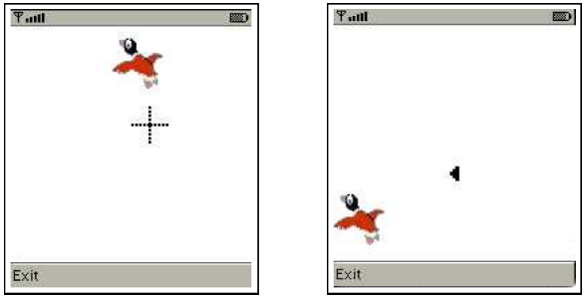
Fig 3.5. Two games generated for the noun \pheasant" and verb \shoot". A duck is in both since it is the closest noun to \pheasant" for which the generator has a sprite. Both are Avoid games with Attacker-verb \shoot", Avoider-noun \duck", and Attacker-noun \bullet". The left game is implemented by the Shooter concrete mechanic and has the player trying to shoot the duck; the right game is implemented by the Dodger concrete mechanic and has the player, as the duck, trying to avoid bullets.

These concrete game mechanics capture the concrete representations and control mappings the system currently knows about. Finally, there is a stock set of sprites, each attached to a noun describing them, that can be used as the graphical representation of any of the objects in any of the games. The end result of the generation process is a recipe for building a game. The game is then built out of the composable classes corresponding to the five sets of stock concrete mechanics (plus input and movement-control classes) to produce a running game. Screenshots of the realizations of two generated games are shown in Figure 3.5.

Common-sense WarioWare generation
In response to a request, a number of games are generated to meet a set of constraints on what games \make sense" in each of the three types of abstract games, and are scored according to a heuristic measure of how \reasonably close" they are to the player's actual request. These games are then built and fed to the player in rapid-fire sequence, much as in Nintendo's original WarioWare, with the games growing increasingly distant from the original request as the system has to stretch further to find games satisfying the thematic request that it hasn't yet used. The original verb, not the prototype, is then used to determine which nouns can be mapped into the game.

Automated game generation is a little-explored area of research that holds great potential, both as a technique that would enable the development of new types of games, and as a research agenda that tackles the problem of machine creativity from the perspective of the generation of highly interactive artifacts. It was described a general framework for viewing this problem, and a prototype system that generates games in the style of WarioWare about user-requested subjects, while respecting common-sense expectations about the roles of verbs and nouns in those games.

Comparison Criteria

Validation: Serious Educational Game Assessment
No validation module has been implemented in this approach.

Serious Educational Game Customization
Though only a subset of the game design problem, procedural content generation would be a useful component of an automated game-design system, allowing it to generate custom content on demand rather than relying on libraries of canned content. Games that customize themselves to music (for example by synchronizing movement in the game to the music's beat) are similar to the goal of customizing games in this part, but it is not game generation per se, since the games are programmed explicitly to respond to music as input, rather than adapted on the fly by a process that explicitly reasons about the game's design.

Serious Educational Game Automation
An approach was described to formalizing game mechanics and generating games using those mechanics, using WordNet and ConceptNet to assist in performing common-sense reasoning about game verbs and nouns.

Pedagogical foundation on Serious Educational Games
In this approach no pedagogical foundation method is used.

Serious Educational Games Content Generation
In this approach no method is used for creating content.

Level content generation

Introducion
In this work, following successes in learning and using user preferences in other areas, it will be presented an automated level generation method for the game of the Mario AI competition. The method learns the preferences for various features that the user/player currently has, based on having the user play a few short given levels and answering a few questions. The testbed is extended to allow for more feature variations and create levels in a three step process. First a graph is created to represent the future cells for the game that fulfills constraints created out of the observed feature preferences (and the answers to the questions) of the user. This graph is then transformed into a two dimensional level for the game keeping the cell connections from the graph. Finally, the individual cell contents are created, again using constraints and preferences observed from the user (and the user’s answers). The user preferences from four players with different skills and genre preferences are collected. The levels created for each of the players show substantial differences, aligning them with the collected player expectations.

OUR APPROACH TO LEVEL GENERATION
The Mario AI platform game has the human player navigate through a world of platforms, holes between platforms, portals connecting different parts of a level (essentially being teleporters), and enemies, like “Goombas” and “Spiked Turtles”. The player character has to jump from platform to platform or on enemies (to kill them) to pass through a level. The player character can make use of “special effects”, like shells and fireballs, and can also collect coins.
A high-level view on level generation: In general, the approach consists of two phases, the user preference elicitation and the level generation based on preference parameters. The latter phase consists of three steps, namely creating a cell graph, conversion of the graph into a grid, and finally creating the individual cells making sure that they fit the grid. The second phase can be performed several times using the results from the first phase due to the use of some randomness in the three steps of the second phase.
A combination of multiple choice questions and player performance in short pre-defined levels are used to get an idea of what kind of level the user would like to play. Two multiple choice questions ask the user about their preferred level of difficulty, and their opinion on different kinds of challenges. The user then plays three pre-defined levels, both to measure their skill level, and to verify the answers provided to the questions. While the user plays the predefined levels a variety of player behaviors are counted, which then are compacted into metrics. Using these metrics allows to determine four basic parameter values for the player, which are then used during the level generation phase. For realizing the second phase, level generation process will be started by creating a directed graph, which describes the number of cells, and which cells may be accessed from other cells. The structure of this graph will control the large scale complexity of the level, including how often the player’s path may diverge and force the player to make a choice, and how much of the content will remain unseen by the player if the most direct route from start to finish is chosen. Figure 3.6 presents an example of such a graph, with the box indicating the shortest path from start to finish.

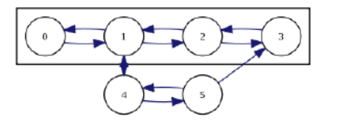
Fig. 3.6: A sample graph.

In the next step, the graph must be converted into a grid representation, which will decide the geographical size and location of each cell. Without the use of a portal system, this conversion is difficult and sometimes impossible. In the final step, content is generated for each cell separately, then assembled into a full level according to the requirements represented by the grid.
Eliciting user preferences: In order to create a level that represents the current preferences of a player, it’s started by asking the player two pre-game questions. The first lets the player indicate one of three sub-genres of the general game, namely Combat, Flow, and Puzzle. The second question asks the player to indicate a difficulty level. The player’s self-evaluation is confirmed by a set of trials used to measure the player’s abilities in a variety of common situations. These trials are static hand-made levels, which are shorter than a typical level but of much greater difficulty.
Graph Generation: The first step in actually creating a level using the method is to create a graph representing a given number, namely 8·puzzle+7, of cells (as nodes) and the intended connections between those cells. For a graph to be acceptable (feasible) for the next steps, irt’s required it to fulfill a set of given (feasibility) constraints. This still leaves quite a number of possible graphs and in order to create a “good” graph, a feasible-infeasible two-population genetic algorithm are used to search for a graph that is “good” with regard to a given fitness function.
Grid Generation: The best (feasible) individual (graph) found by the genetic algorithm from the last step is used as the input to the second step of the method, the grid generation step. Since there are usually several different possibilities where a cell can be placed in the grid, the grid generation is essentially an or-tree based search. At any given depth in this search tree, the next cell to be added is the cell named at the same depth in the placement order.
Cell Content Generation: With the grid created by the last step, the remaining task is to fill the cells in the grid with content. The candidate cell is then created as a copy of the parent cell, with the new component added in an appropriate position. Cells are scored based on quantities derived from an accessibility graph which describes the available paths that a player and enemies may take through the level. It is generated by coarse-grained traversal of the level (equating possible positions with entire blocks).

EVALUATION: the level generation method aims at creating a level for a particular person respecting the current moods and wishes of this person. Therefore it has been chosen a show-and-telllike approach to evaluate the method. The speed with which a player moves indicates experience with the game, particularly with the flow aspect. Users who moved slower, covered less ground and killed fewer enemies, the clutter rating has been increased. As with coins, holes will appear in every level regardless of supplied parameters. What does vary with respect to flow is the size and frequency of these holes. In Figure 3.7a, holes are nearly everywhere except where they would allow a “shortcut” between two cells which are intended to be separate.
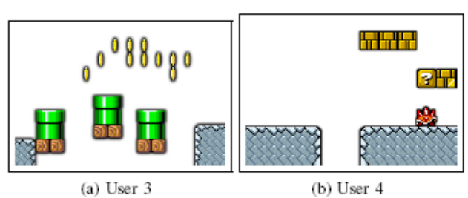
Figure 3.7: Extreme cases with respect to flow.

A method is presented for creating levels for platform games based on eliciting the preferences of a particular player and allowing for different subgenres of platform games. The three step process of creating levels allows for making use of the player preferences on different levels of abstraction and also allows for focusing the search on particular aspects of the game only, which – together with appropriate constraints – keeps the search spaces manageable. In the evaluations, the created levels reflected the wishes of the players they were created for.

Comparison Criteria
Validation: Serious Educational Game Assessment
In the evaluation, the user preferences from four players was collected with different skills and genre preferences. The fitness function evaluates the individuals and is a weighted sum of the following four measures: Average Outgoing Edges - EO(), Start Node Connections - ES(), End Node Connections - EE(), Path Length - L(). In the evaluations, the created levels reflected the wishes of the players they were created for.

Serious Educational Game Customization
Our method learns the preferences for various features that the user/player currently has, based on having the user play a few short given levels and answering a few questions. In order to create a level that represents the current preferences of a player, it’s started by asking the player two pre-game questions. The first lets the player indicate one of three sub-genres of the general game, namely Combat, Flow, and Puzzle. The second question asks the player to indicate a difficulty level.

Serious Educational Game Automation
In this work, following successes in learning and using user preferences in other areas, it will be presented an automated level generation method for the game of the Mario AI competition. The method learns the preferences for various features that the user/player currently has, based on having the user play a few short given levels and answering a few questions.

Pedagogical foundation on Serious Educational Games
In this approach no pedagogical foundation method is used.

Serious Educational Games Content Generation
The individual cell contents are created, using constraints and preferences observed from the user (and the user’s answers).

An Offline Planning Approach to Game Plotline Adaptation

Introduction
Role-playing games, and other types of contemporary video games, usually contain a main storyline consisting of several causally related quests. As players have different motivations, tastes and preferences, it can be beneficial to customize game plotlines. In this section, an offline algorithm for adapting human-authored game plotlines for computer role-playing games will be presented to suit the unique needs of individual players, thereby customizing gaming experiences and enhancing re-playability. On-demand entertainment refers to the possibility that one can, at any time, request an entertainment experience that is significantly different from those previously consumed. In addition, entertainment artifacts should be customized or configured to suit every player’s unique motivation, tastes, history and ability. This section addresses on-demand and customized entertainment in the context of generating plotlines for role-playing games.
The contribution of this section is a system that solves the plotline adaptation problem: Given a complete, human-authored plotline consisting of sequence of quests, a library of quest structures, and a set of requirements about what an optimal gameplay experience should be for a particular user at a particular time, produce a sound, coherent variation that meets the requirements while retaining as much of the original plotline as possible. Offline processing affords the possibility to making globally optimal decisions about plotline structures, complimenting online adaptation techniques known as interactive storytelling. The supposed technique is justified with a discussion on theoretical authoring gains and empirical evaluation of the algorithm[5].

The Architecture of the Proposed System

Game Plot Adaptation
Figure 3.8 shows the adaptation pipeline for game plotlines. The game adaptation process takes a main plotline, a library of quest structures, and a set of player requirements as input. A player model generates a set of requirements, based on the player’s preferences, history, and a model of novelty. Importantly, the cycle between player and adaptation implies that games can be changed after each time it is played, thereby increasing its replayability. Possible actions in the virtual world are known to the system.
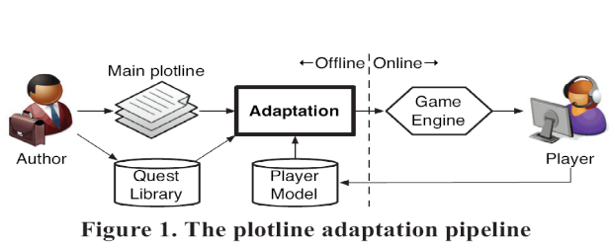
Figure 3.8. the plotline adaption pipeline

Plot Representation
Following others, the plan-like representations of narrative are employed because they capture causality and temporality of action and provide a formal framework built on first principles, such as soundness and coherence, for selecting and ordering events. However, unlike a plan meant for execution, it’s used plans as descriptions of events expected to unfold in a virtual world. Each action represents a formal declaration of an event that can be performed by the player or non-player characters, or occurs as a consequence of physics laws in the virtual world.
The specific representation builds on partial-order plans. In this system, quests are represented as top-level abstract events. A quest has a single effect, guest complete (guest-X), and may or may not have any preconditions. Figure 3.9 shows a complete plotline consisting of two quests. Primitive actions are shown as solid rectangles and abstract actions are shown as rounded rectangles. The hierarchical relationship between events is reflected in the containment relationships of rectangles.
A coherent narrative is one in which, in the DAG formed by events and causal links, there is a path from each event to a significant outcome. Any event that is not part of some path to the outcome situation is referred to as a dead end[5].

Player Model
The player's preferences are modeled as a function of previously selected quests. Each quest, in turn, is represented as a feature vector in a semantic space. A technique is utilized to determine preferences over quests via ratings after gameplay concludes. In addition, a novelty model favors quests that are appropriately novel to the player based on his or her history so that he or she would be neither bored nor unpleasantly surprised. Computing a weighted sum of utility by preference and utility by novelty, the result is the selection of the k quests with the greatest utility that should be included in the game plotline.

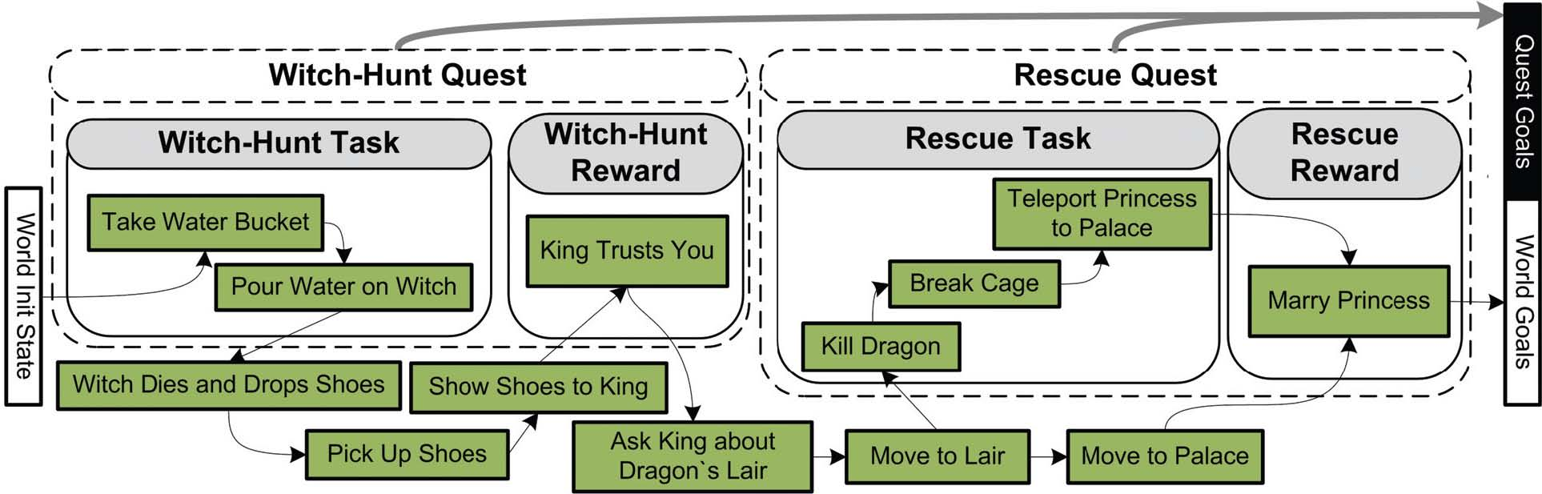
Figure 3.9. Original game plotline before adaptation[5]

Adaptation Algorithm

The plot adaptation module receives as input the following components:

- A complete plotline – a partially ordered, hierarchical plan – composed of events within and outside of quests.
- A set of plot requirements: guest complete (guest-X) propositions specifying what quests should be included, and corresponding world-level outcome propositions.

The adaptation algorithm is shown in Figure 3.10. The main loop is the standard plan refinement search loop.

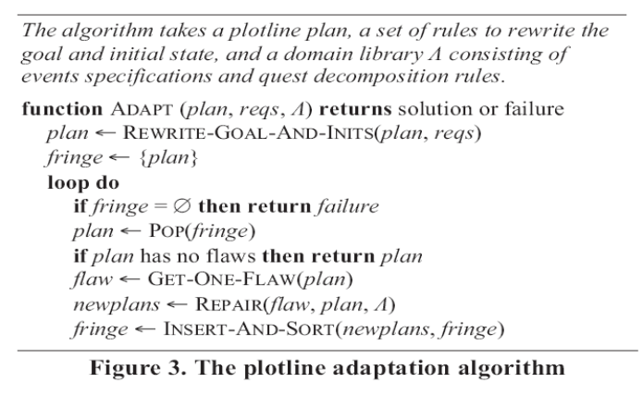
Figure 3.10. the plotline adaption algorithm

Plotline adaptation scales up the ability to deliver customized experiences without significantly increasing the authoring effort. The variability is focused– the number of distinct stories – as the metric.
A one-time authoring cost by a domain engineer is incurred in the development of a world domain model, containing specifications for primitive events, abstract events (including quests), and decomposition rules. The payoff is a theoretically exponential leverage. The adaptation process can theoretically produce as many variations of a given plotline as the size of the power set of available quests. Thus, one strength of plotline adaptation is the ability to opportunistically discover new transitions between quests based on the world model [5].

Comparison Criteria

Validation: Serious Educational Game Assessment
No validation module has been implemented in this approach.

Serious Educational Game Customization
In this section, an offline algorithm was presented for adapting human-authored game plotlines for computer role-playing games to suit the unique needs of individual players, thereby customizing gaming experiences and enhancing re-playability.

Serious Educational Game Automation
No automation method has been used in this approach.

Pedagogical foundation on Serious Educational Games
In this approach no pedagogical foundation method is used.

Serious Educational Games Content Generation
In this section, the use of automated content generation was explored as a means of scaling up the delivery of on-demand, customized entertainment content. In the realm of automated content generation, plotlines may be generated from scratch [5].

Automation in E-learning Application

Automating e-Learning: The Higher Education Revolution

Introduction

5th Generation Distance Education: The Emerging e-University
The fifth generation distance education (The Intelligent Flexible Learning Model) will not be presented solely as a set of abstract principles, but will be illustrated within the context of the e-University Project.
The Award, presented by the Prime Minister at Parliament House in Canberra, focused on the preparation of graduates of both undergraduate and postgraduate courses and the university as a whole for the emerging ‘e-world’: http://www.usq.edu.au/GUG2000.htm The e-University Project was conceptualized in terms of three fundamental foci: the e-Information repositories, a variety of e-Applications and the e-Interface respectively. A graphic overview of University of Southern Queensland (USQ)’s e-University Project is presented in Figure 4.1.

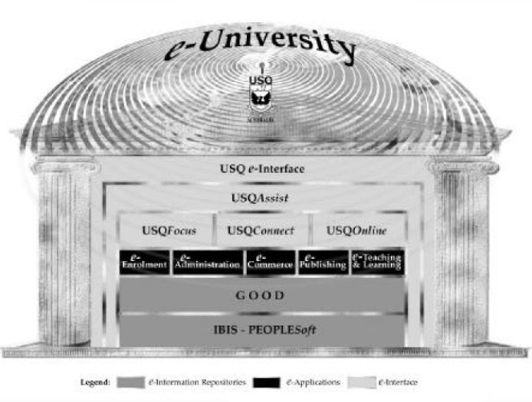
Fig. 4.1: Overview of USQ’s e-University Project.[4]

Learner Relationship Management
The USQAssist initiative is deploying tracking and automation tools to manage the interaction between the University and both its existing and prospective students. The most efficient, cost–effective way to manage the 24 x 7 challenge is to deploy effective automation tools, as opposed to running three shift student service desks or employing online tutors in different continents.
The deployment of e-Customer Relationship Management (e-CRM) software as “Learner Relationship Management” will ultimately enable the use of a single toll free number integrated with an email–based enquiry tracking system that will exploit the fundamental strengths of the Internet in enhancing communication and managing information. The USQ e-interface is being developed through the application of a web services approach. The implementation of the approach has entailed the creation of an Internet Systems Design, Development and Integration Team, and an Online Systems Technical Management Committee (OSTMC).
The OSTMC also provides a useful forum to support the implementation of USQ’s on campus wireless networking initiative http://www.usq.edu.au/its/wireless.

Automating e-Learning
In the USQ approach, many teaching staff make use of discussion groups, which entail students posting “reflections” via the asynchronous computer mediated communication (CMC) system. The teaching staff also post comments.
In the same vein, members of the teaching staff respond to student questions posted to the discussion group. Further, the experience demonstrates that other students often comment on the issues raised thereby enriching the depth and quality of the dialogue. The value of these contributions is particularly useful where students are giving examples of applications in different cultural contexts. While such fears can be allayed by the use of “one-to many” communication systems such as bulletin boards, mailing lists and threaded discussions, the underlying resource model is not significantly different from conventional on campus teaching, with a staff member being necessary to manage groups of approximately 20 students to maintain a reasonable quality of interaction and academic support. In contrast, the fifth generation Intelligent Flexible Learning Model has the potential to deliver major economies of scale in managing teaching and academic support through the exploitation of automated response systems (Fig 4.2)[4].
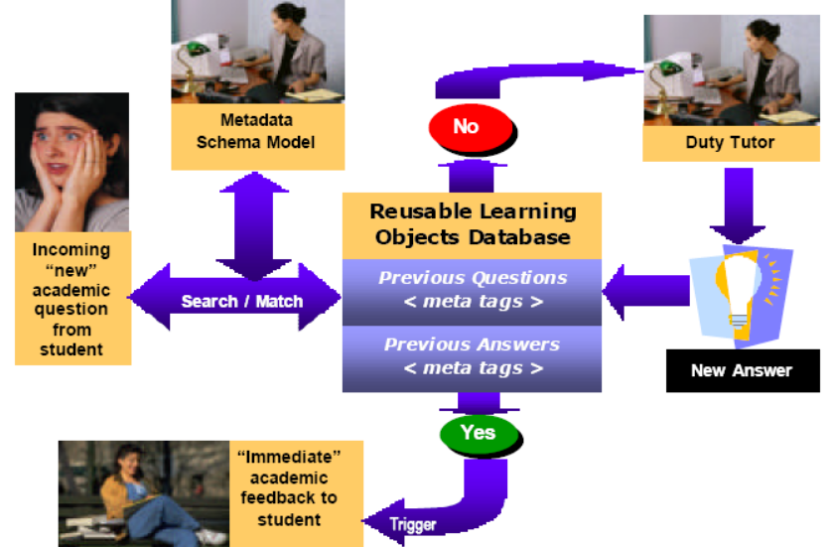
Fig. 4.2: Schematic representation of USQ’s 5th Generation Academic Productivity Enhancement System[4]

Upon receipt of an electronic query from a student, the staff member references the incoming question to a metadata schema model which has been devised for the course in question; the search engine then seeks an appropriate match with a previously asked question, which if successful, triggers a potential range of answers to the current question without further human intervention.
At this stage of development, the design of the system entails a tutor checking the validity of the match between the current question and the answers generated from the database before forwarding to the students with a single click of the mouse. Such a quality control mechanism may become redundant in the future. If no appropriate match is discovered in the database of previously answered questions, the query is automatically routed to the relevant tutor for an appropriate response, which is then added to the database with a single point and click.
Depending on the pedagogical design of the course, these responses can be directed to the whole cohort of students, to groups of students, or to individuals. The system has the advantage of providing more-or-less immediate pedagogical advice to students, a significant increase in institutional responsiveness, at minimal variable cost. It is worth noting that this system is not just aimed at reducing costs, USQ has a research program producing empirical evidence aimed at to validating the potential pedagogical efficacy of the approach, as illustrated by the following brief discussion of underlying instructional design theory and an associated exemplary investigation[4].

Comparison Criteria

Validation: Serious Educational Game Assessment
At the stage of development, the design of the system entails a tutor checking the validity of the match between the current question and the answers generated from the database before forwarding to the students with a single click of the mouse.

Serious Educational Game Customization
As mentioned before, no accessibility was used to minimize the cost and effort needed for student with physical problems.

Serious Educational Game Automation
The USQAssist initiative is deploying tracking and automation tools to manage the interaction between the University and both its existing and prospective students. The design of the system entails a tutor checking the validity of the match between the current question and the answers generated from the database[4].

Pedagogical foundation on Serious Educational Games
The system has the advantage of providing more-or-less immediate pedagogical advice to students, a significant increase in institutional responsiveness, at minimal variable cost. It is worth noting that this system is not just aimed at reducing costs, USQ has a research program producing empirical evidence aimed at to validating the potential pedagogical efficacy of the approach, as illustrated by the following brief discussion of underlying instructional design theory and an associated exemplary investigation[4].

Serious Educational Games Content Generation
In this approach no method is used for creating content.

Recommender system based on user-generated content

Introduction
Recommender systems apply statistical and knowledge discovery techniques to the problem of making recommendations during live user interaction. This part describes a novel approach of building recommender systems for the Web with the aid of usergenerated content. Recently certain communities of Internet users have engaged in creating high quality peer reviewed content for the Web. In this approach it’s been planning to extract the semantics of such user-generated content and to use these semantics to make more useful recommendations.
Recommender systems attempt to predict items (web pages, movies, books) that a user may be interested in, given some information about the user's profile. Collaborative filtering is the most popular approach to building such systems. Another method in generating recommendations is based on predicting users’ interests based on his/her past preferences. Both systems suffer from a number of deficiencies: mainly they both fail to recommend novel interesting topics.
In this part, it’s been avoided this difficulty by generating recommendations of Web pages with the aid of semantics, extracted from user-generated content. It is obvious that building a recommender system for Web pages that extracts semantics from all of the content on the Web would be very resource demanding. Instead it’s picked Wikipedia as source of user-generated semantics, which is a comprehensive and up-to-date corpus of knowledge and relationships between concepts.
Wikipedia
User-generated content refers to various kinds of content that is produced or primarily influenced by endusers. However, average quality of Web content is quite poor, as evidenced by vast amounts of Web spam and unverified information submitted by non-authoritative users. Therefore, instead of using the Web, Wikipedia is chosen as base, since it is a body of usergenerated content that is all encompassing and at the same time of high quality and peer reviewed.
Problem formulation
The main goal of this research is to develop a recommender system for the Web based on user generated content and novel semantic techniques. Instead of recommending web pages or sites, the system will recommend blogs. The overall system architecture is presented in figure 4.3. Within the content processing framework there two key processes: Wikipedia analysis (top of figure) and blogs processing (bottom of figure). Wikipedia is analyzed and create an ontology based on its structure. Then concepts are extracted and ranked from the blogs , making use of the ontology. Also in this stage blogs and ontology are associated through concepts. Then these associations are used to find blogs similar to users preference set (set of blogs that characterizes users interests) with the aid of the ontology.

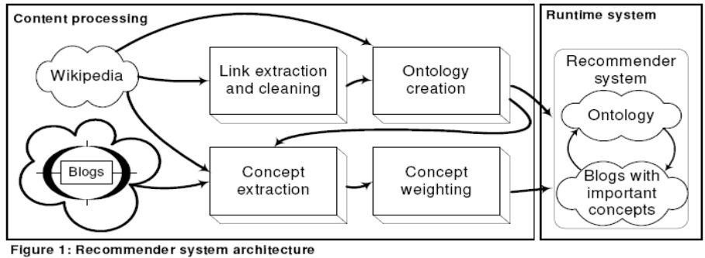
Fig 4.3: Recommender System Architecture

Cleaning Wikipedia links: Though this is only a small part of information could be extracted from Wikipedia, users able to get results very quickly and rate their quality. For solving link cleaning task it is necessary to investigate how such low-quality links appear. Occasionally a rogue user will insert a bunch of irrelevant links into an otherwise quality section. In order for these methods to be applicable it’s needed to make sure that Wikipedia has the same properties.
So, web graph relates to the class of scale-free networks with most distinguishing characteristic are that their degree distribution follows a power law relationship. The second property of this class of networks is self-similarity: a large-enough supporter set should behave similar to the entire Web. The basic idea is to analyze rank distribution of some page in its neighborhood. Therefore emerging spam detection algorithms require the following properties: Power-law link distribution and Self-similarity. Link structure of the Wikipedia follows the power-law distribution and it follows that self-similarity holds for Wikipedia.
Ontology extraction: For the work it can’t be used only the link structure to make recommendations. So it’s needed to extract additional knowledge from Wikipedia that will help users select a few relevant links for recommendations. Therefore the second stage of Wikipedia processing deals with extracting semantic information from link and sections.
For now it will be used categories, “see also” links and general links in the sections. List of categories form a directed graph over the sections of Wikipedia, which can be very useful in pruning irrelevant links when making recommendations.
Web logs processing: In order to find blogs most similar to user preference set it’s necessary to extract terms from each blog and correlate these terms with concepts from the ontology. This will enable users to make recommendations based on these concepts. When blogs are correlated with concepts each blog will become associated with a large number of concepts. In order to identify essential concepts it’s used a modified tf-idf weighting scheme.
Generation of recommendations:At runtime the recommender system derives top-N recommendation from the ontology based on users preference set. Little research has been done on this topic. An ontology-based information retrieval model exploits ontology-based knowledge bases to improve search over large documents. This approach includes an ontology-based scheme for the semiautomatic annotation and retrieval of documents.

In this part it’s proposed a novel architecture for building recommendation systems and formulate the major directions of future work.

Comparison Criteria
Validation: Serious Educational Game Assessment
In this approach no method is used for validation.

Serious Educational Game Customization
In the former approach new content is compared against user’s past preferences and similar items are recommended via collaborative filtering method.

Serious Educational Game Automation
In this approach the semantics of such user-generated content was extracted and to use these semantics to make more useful recommendations via collaborative filtering method.

Pedagogical foundation on Serious Educational Games
In this approach no method is used for pedagogical foundation.

Serious Educational Games Content Generation
This part describes a novel approach of building recommender systems for the Web with the aid of user-generated content. New content is compared against user’s past preferences and similar items are recommended by generating recommendations of Web pages with the aid of semantics, extracted from user-generated content.

E-learning recommendation system

Introduction
In this study, the user-based collaborative filtering method is chosen as the primary recommendation algorithm, combined with online education. The requirement of a webbased e-learning recommendation system is analyzed, and divide the system workflow into five sections: data collection, data ETL, model generation, strategy configuration, and service supply. Moreover, an architecture is proposed, based on which further development can be accomplished. In this architecture, there are seven modules, and four of them are core modules: recommendation models database, recommendation system database, recommendation management, data/model management.

Collaborative Filtering
ALGORITHMS
Learner-to-Learner correlation recommender systems recommend courses to a learner based on the correlation between that learner and other learners who have studied courses from the E-Learning site. This technology is known as “collaborative filtering”, because it originated as an information filtering technique that used group opinions to recommend
information items to individuals. In e-learning systems this is done in two ways. One, by having learners explicitly rate courses, in which case the system is moved part of the way towards Manual; the other, the learning is implicit from the studying patterns or click-stream behavior of the learners, in which case the system is pure Automatic. The proportion of actual studying hours to the total hours of the course is recorded as the implicit rating scores, and transformed to corresponding explicit rating scores, from 1 to 5. The learners’ rating scores can be donated in a m*n matrix, where m is the number of users, n is the number of courses, and Rj,k donates the rating of Coursek given by learnerj.
The most important step in CF-based recommender systems is that of computing the similarity between learners as it is used to form a proximity-based neighborhood between a target customer and a number of like-minded customers. In the e-learning recommendation system proximity between two learners a and b is measured by computing the Pearson correlation corrab, which is given by
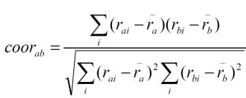 (1)
The final step of a CF-based recommender system is to derive the top-N recommendations from the neighborhood of customers. The association rule-based recommendation is used for performing the task. This technique is based on the association rule-based top-N recommendation technique. However, instead of using the entire population of learners to generate rules, this technique only considers the l neighbors while generating the rules. Non-personalized recommender systems is applied in e-learning system as well, which recommends courses to learners based on what other learners have said about the products on average.

SYSTEM DESIGN
The recommendation system is analyzed independently from the e-learning system, to reduce the extra burden of the e-learning site. The union of e-learning services, and recommender system services supplies the personalized recommending services together.
The central part of the services is the recommender system. The main workflow is the following five steps: Data Collection, ETL(extracted, transformed, loaded to data warehouse),Model Generation, Configuration, Service Supply.
The process above is a constant circuit, when the data in transaction database updates to a certain degree, the datasets and models in data warehouse have to be updated, in order to track the change of the users’ behaviors. The updating frequency differs to the system
requirements, usually at fixed period. This recommendation system consists of online and
offline parts, the online part receives the requirements, run the corresponding algorithm, and generates recommendation results; the offline part collects data, preprocess data and generates recommendation models. The Fig 4.4. gives out the architecture of the recommendation system.
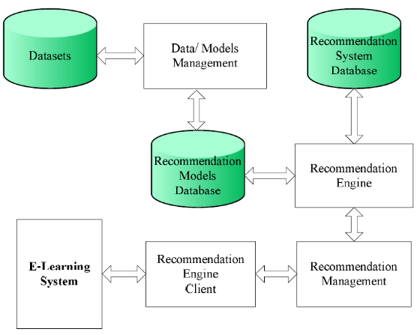
Figure 4.4. Architecture of E-Learning System

Some core modules in Fig. 4.4 are introduced as following: Recommendation Models Database, Recommendation System Database, Recommendation Management, Data/model Management.

Comparison Criteria
Validation: Serious Educational Game Assessment
In this approach no method is used for validation.

Serious Educational Game Customization
The user-based collaborative filtering method is chosen as the primary recommendation algorithm, combined with online education. Recommender e-learning site automatically recommend interesting and useful courses to users.

Serious Educational Game Automation
Non-personalized recommender systems is applied in e-learning system as well, which recommends courses to learners based on what other learners have said about the products on average.Non-personalized recommender systems are automatic, because they require little learner effort to generate the recommendation.

Pedagogical foundation on Serious Educational Games
In this approach no method is used for pedagogical foundation.

Serious Educational Games Content Generation
In this approach no method is used for Content Generation.

EXPERT PERSONALIZED E-LEARNING RECOMMENDER SYSTEM

Introduction
This part proposes a framework for expert personalized e-learning recommender system (EPERS). An EPERS can help learners in finding learning materials that best suits their needs. In the proposed framework a rule-based expert system is developed to find suitable learning materials that best meet each learner’s requirements.
A Framework of EPERS
This section explains the main components of the EPERS as shown in Fig 4.5. This system consists of six components: Gathering Learner Information (GLI), Materials Recommendation Creation (MRC), Learner Profile (LP), Expert System (ES), Domain Knowledge Management (DKM) and Domain Knowledge Tree (DKT).
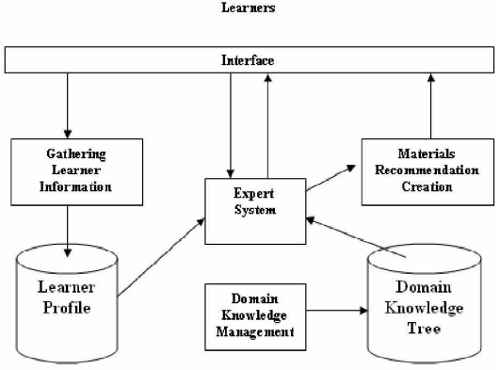
Fig. 4.5 The framework of EPERS

Through GLI the learner initially registers to the system, during registration some personal settings are saved in the learner profile. The LP consists of learner’s: style, background, type (part time, full time), etc. In addition LP contains of all the information about learners, like their preferences, interests and knowledge levels, which can be obtained during the registration process. In DKM, the tutor can manage the material for the online course through creating and designing the DKT. The root of the DKT is the course name. The course is divided into chapters and that chapters are divided into sections and subsections. By using a rule-based expert system, the creation of final recommendation material list that based on learner’s requirements and on every answer given by the learner is achieved.

Expert System: Now that the data representation methodology of the expert recommendation system has been discussed, the focus of this part will turn to make the recommendation process. Any such accuracy requires the application to mimic the knowledge base of an experienced tutor. This knowledge base is encapsulated and applied by an expert system shell. Ideally, expert system engineers would be able to construct a general problem-solving machine, with an infinite knowledge base and comprehension of all problem-solving techniques . Since inference is an integral part of an expert system, it is helpful to implement an explanation facility within the expert system to explain the reasoning that occurred during the expert system’s deductions.

The scenarios steps of EPERS:
1. The expert system asks questions
2. The Learner answers
3. The expert system asks new questions, based on the previous answer
4. The learner thread (question-answer thread) inside the decision is recorded in History.
- Back to 2
A rule-based system maintains a collection of knowledge nuggets called facts. This collection is known as the knowledge base. It is somewhat akin to a relational database, especially in that the facts must have a specific structure.

Applications of EPERS
In order to deal with the multi-background learner situation, lecturers often indicate many choices of learning materials for each topic of the subject, and learners often rely on incomplete information, from their classmates and friends, when deciding which of the indicated learning materials to read and which of exercise questions to do.

Table 4.1: an example of learner information
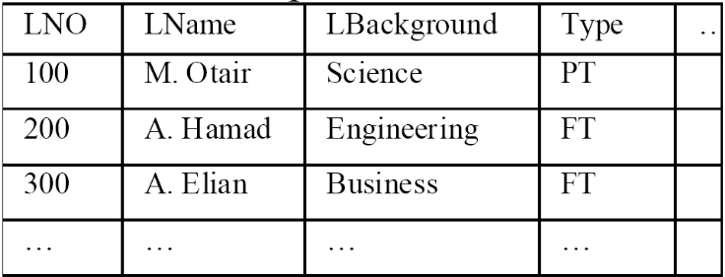
The proposed EPERS is expected to support learners in learning material choosing and can therefore handle such situation. Table 4.1 shows one of the main tables in the course learner MIS. The following line shows an example of recommendations.
Jess> (assert (Learner (LNo 100) (LName “M. Otair”)
(LBackground “Science) (section “Business_Rule”)))
<Fact-1>
Jess> (run)
M. Otair You have to read Business_rule section.

This part presents a framework of an expert personalized e-learning recommendation system and explains the main components of the system. The EPERS enhanced the productivity of learners/tutors in e-learning environments.

Comparison Criteria
Validation: Serious Educational Game Assessment
In this approach no method is used for validation.

Serious Educational Game Customization
This part proposes a framework for expert personalized e-learning recommender system (EPERS). An EPERS can help learners in finding learning materials that best suits their needs. In the proposed framework a rule-based expert system is developed to find suitable learning materials that best meet each learner’s requirements.

Serious Educational Game Automation
In the proposed framework a rule-based expert system is developed to find suitable learning materials that best meet each learner’s requirements.

Pedagogical foundation on Serious Educational Games
In this approach no method is used for pedagogical foundation.

Serious Educational Games Content Generation
In this approach no method is used for Content Generation.

Conclusions and Future Work

Table of Comparison Criteria

As mentioned previously, five approaches were compared to each other through 5 comparison criteria, which are shown in below table:

Table 6.1. Comparison Criteria
CC  Approaches | Validation | Pedagogical foundation | Customization | Automation | Content Generation
The case of 1492 |  |  | - Accessibility (by input/output modules integrated with the engine) | - analyzing the game description XML files and art resources
My first day at work |  |  | - Accessibility (by input/output modules integrated with the engine) | - Game editor core
Petri Nets for Representing Story Plots in Serious Games | - by application TEST | - Interactive–narrative
Cellular Automata and DEVS Methodologies |  |  |  | - cellular automaton | - DEVS methodology
An Offline Planning Approach to Game Plotline Adaptation |  |  | - offline algorithm for individual players |  | - plotline
Modeling Player Experience for Content Creation | - cross-validation technique | - SLP modeling procedure feature of | - Infinite Mario Bros |  | - levels and game modes
Automated Game Design |  | - automated game-design system |  | - WordNet  - ConceptNet
Level content generation | - fitness function | - two pre-game questions |  | - automated level generation method | - individual cell contents
Automating e-Learning | - tutor checking | - immediate pedagogical advice to students |  | - tracking and automation tools
Recommender system based on user-generated content  Serious Educational Game Customization |  |  | - collaborative filtering method (user’s past preferences &  similar items) | - collaborative filtering method | - semantics
E-learning recommendation system |  |  | - user-based collaborative filtering method | - Non-personalized recommender systems
EXPERT PERSONALIZED E-LEARNING RECOMMENDER SYSTEM |  |  | - EPERS | - rule-based expert system

References
// use correct format for book, journal, conference part
// avoid websites
- Paul Flynn, Li Zhou, Kurt Maly, Steven Zeil, and Mohammad Zubair, Automated Template-Based Metadata Extraction Architecture, ICADL 2007, LNCS 4822, pp. 327–336, Springer-Verlag Berlin Heidelberg 2007.
- Javier Torrente, Ángel del Blanco, Ángel Serrano-Laguna, José Ángel Vallejo-Pinto, Pablo Moreno-Ger, Baltasar Fernández-Manjón, Towards Universal Game Development in Education Automatic and Semiautomatic Methodologies, Springer-Verlag Berlin Heidelberg 2011.
- A Model-Driven Framework to Support Development of Serious Games for Game-based Learning, School of Computing and Mathematical Sciences, Liverpool John Moores University, UNITED KINGDOM, 2010 Developments in E-systems Engineering, IEEE Computer Society, 2010 .
- Cheng-ping Chen, Ju-ling Shih, A Prototype on a Meta-model for Designing Instructional Pervasive Games, Department of Information and Learning Technology, National University of Tainan, 2012 Fourth IEEE International Conference On Digital Game And Intelligent Toy Enhanced Learning, 2012.
- Sara de Freitas, Learning in Immersive Worlds: A review of game-based learning, Prepared for the JISC e-Learning Programme.

Previous:

- C. Shaun Longstreet, Kendra Cooper, A Meta-model for Developing Simulation Games in Higher Education and Professional Development Training, IEEE 17th International Conference on Computer Games, Kentucky, USA ,2012
- S. Tang, M. Hanneghan, A Model-Driven Framework to Support Development of Serious Games for Game-based Learning, School of Computing and Mathematical Sciences, Liverpool John Moores University, UNITED KINGDOM, 2010 Developments in E-systems Engineering, IEEE Computer Society, 2010 .
- Cheng-ping Chen, Ju-ling Shih, A Prototype on a Meta-model for Designing Instructional Pervasive Games, Department of Information and Learning Technology, National University of Tainan, 2012 Fourth IEEE International Conference On Digital Game And Intelligent Toy Enhanced Learning, 2012.
- Sara de Freitas, Learning in Immersive Worlds: A review of game-based learning, Prepared for the JISC e-Learning Programme.
- Jeannette Bennett, Kendra Cooper, Lirong Dai, Aspect-oriented model-driven skeleton code generation: A graph-based transformation approach, Science of Computer Programming 75, pp: 689_725, 2010.
- Antti Kirjavainen, Development of Game-Based Learning Environments – Constructing a Quality Multi-Disciplinary Development Process, University of Jyvaskyla, Department of Mathematical Information Technology & Agora Center, Dissertation in Information Technology, October 6, 2009.
- Masoud Hemmasi, Lee A. Graf, Illinois State University, EDUCATIONAL EFFECTIVENESS OF BUSINESS SIMULATION GAMING:A COMPARATIVE STUDY OF STUDENT AND PRACTITIONER PERSPECTIVES, Development In Business Simulation & Experiential Exercises, Volume 18, 1991.
- S. Tang, M. Hanneghan, Fusing Games Technology and Pedagogy for Games-Based Learning Through a Model Driven Approach, School of Computing and Mathematical Sciences, Liverpool John Moores University, Liverpool, UNITED KINGDOM, 2011 IEEE Colloquium on Humanities, Science and Engineering Research (CHUSER 2011), Dec 5-6, Penang, 2011.
- Nathan Balasubramanian,Brent G. Wilson, GAMES AND SIMULATIONS, Society for Information Technology and Teacher Education (SITE), 2005.
- Tsung-Li Wang, Ya Fen Tseng, Learning Effect for Students with Game-based Learning on Meta-Analysis, The 6th International Conference on Computer Science & Education (ICCSE 2011), pp. 1291-1295, August 3-5, 2011. SuperStar Virgo, Singapore, 2011.
- Javier Torrente, Pablo Moreno-Ger, Baltasar Fernández-Manjón (2008). Learning Models for the Integration of Adaptive Educational Games in Virtual Learning Environments. Proceedings of the 3rd International Conference on E-learning and Games (Edutainment 2008), Nanjing, China. Lecture Notes in Computer Science 5093, pp. 463–474.
- Miroslav Minović, Miloš Milovanović, Mladjan Jovanović, Dušan Starčević, Model Driven Development of User Interfaces for Educational Game, HSI 2009 Catania, Italy, May 21-23, 2009
- Lina Marcela Morales, David Mendez-Acuna, Willy Montes, Model Driven Game Development - Case Study A MTC for maze game prototyping Departamento de Ingeniera de Sistemas y Computacion, Universidad de los Andes, Colombia.
- Marcio de O. Barros, Alexandre R. Dantas, Gustavo O. Veronese, Claudia M. L.Werner, Model-driven Game Development: Experience and Model Enhancements in Software Project Management Education, Softw. Process Improve. Pract. pp. 411–421. 2006.
- Miroslav Minovic, Milos Milovanovic, Dusan Starcevic, Modelling Knowledge and Game Based Learning: Model Driven Approach, Journal of Universal Computer Science, vol. 17, no. 9 pp. 1241-1260. 2011.
- Diana Oblinger, Simulations, Games, and Learning, EDUCAUSE, May 2006.
- STEPHEN TANG, Martin Hanneghan, State of the Art Model Driven Game Development: A Survey of Technological Solutions for Game-Based Learning, Journal of Interactive Learning Research (201 1) 22(4), pp: 551 -606.
- Josephine M. Randel, Barbara A. Morris, C. Douglas Wetzel and Betty V.Whitehill, The Effectiveness of Games for Educational Purposes: A Review of Recent Research, Simulation & Gaming, 1991.
- Kendra Cooper, C. Shaun Longstreet, Towards Model-driven Game Engineering for Serious Educational Games: Tailored Use Cases for Game Requirements, IEEE 17th International Conference on Computer Games, Kentucky, USA ,2012.

Appendix A. title here

